Composite Bitmap Index Demo

Login as DBA.

Remove all the cached data from buffer, all the sql statements from shared pool and set the tracing on by executing the following 3 commands.

Alter system flush buffer_cache;
Alter system flush shared_pool;
SET AUTOTRACE ON

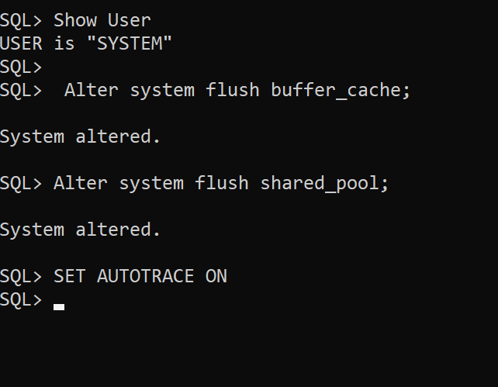

Let’s create a copy of Sales table as Sales3 in the Scott’s user account.

Create Table Scott.Sales3
As
Select * from Scott.Sales;

The Sales3 table of user Scott has 30,000 rows in total.

There is a column Color which has 6 distinct values, i.e., Blue, Black, White, Yellow, Green and Red.

There is one more column Size which has 5 distinct values, i.e., S, M, L, XL and XXL.

Each color has records of each size type.
For e.g., for a combination of Black color and L size there are 1335 records!

Let’s execute a select statement on Scott user’s Sales table to get the number of records (i.e., number of transactions done) for the above combination when there is no composite index created.

Alter system flush buffer_cache;
Alter system flush shared_pool;
SET AUTOTRACE ON
Cle Scr

select count(*) from Scott.Sales3
where color = 'Black' And TSize = 'L' ;

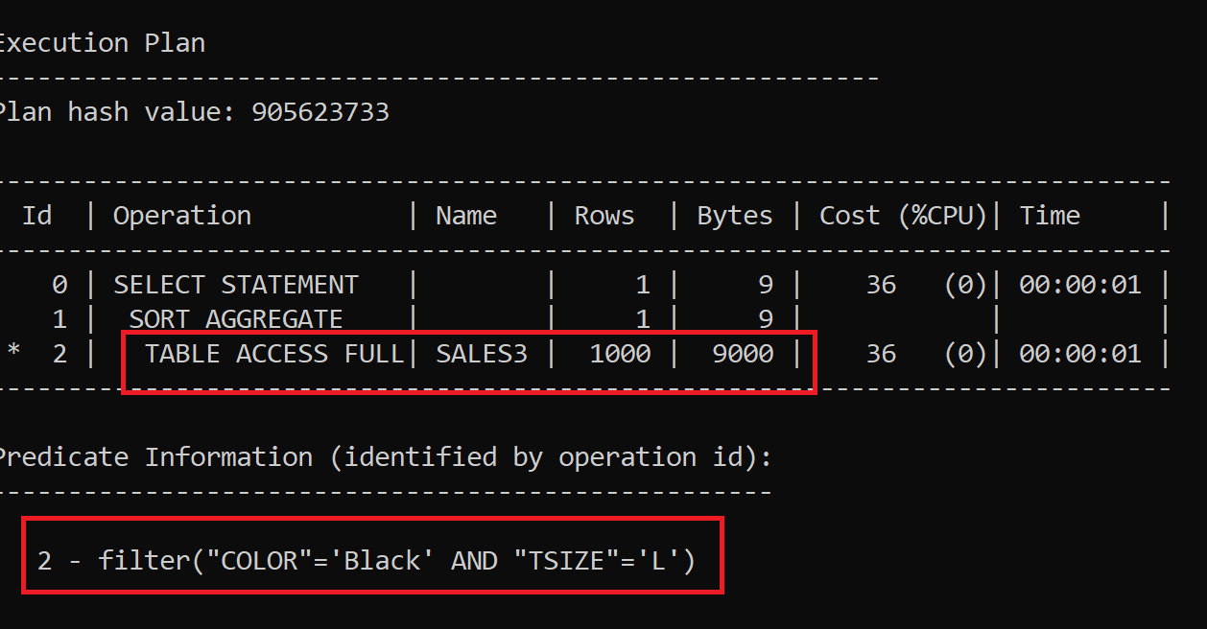

Notice that a full table scan has happened, which will slow down the query execution.

Again, remove all the cached data from buffer, all the sql statements from shared pool and set the tracing on by executing the following 3 commands.

Alter system flush buffer_cache;
Alter system flush shared_pool;
SET AUTOTRACE ON

Now let’s create a bitmap index on only column Color of Scott’s sales table.

Create Bitmap Index Scott_Sales3_Color
on Scott.Sales3(Color);

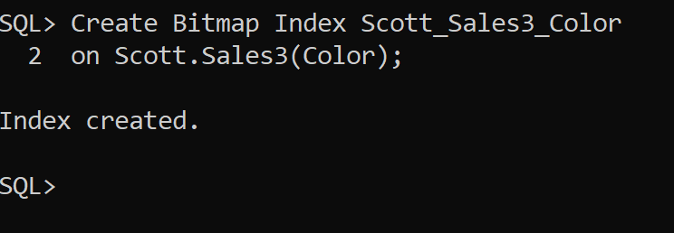

After indexing the column again reset memory and environment

Alter system flush buffer_cache;
Alter system flush shared_pool;
SET AUTOTRACE ON
Cle Scr

Now execute the same select statement:

select count(*) from Scott.Sales3
where color = 'Black' And TSize = 'L' ;

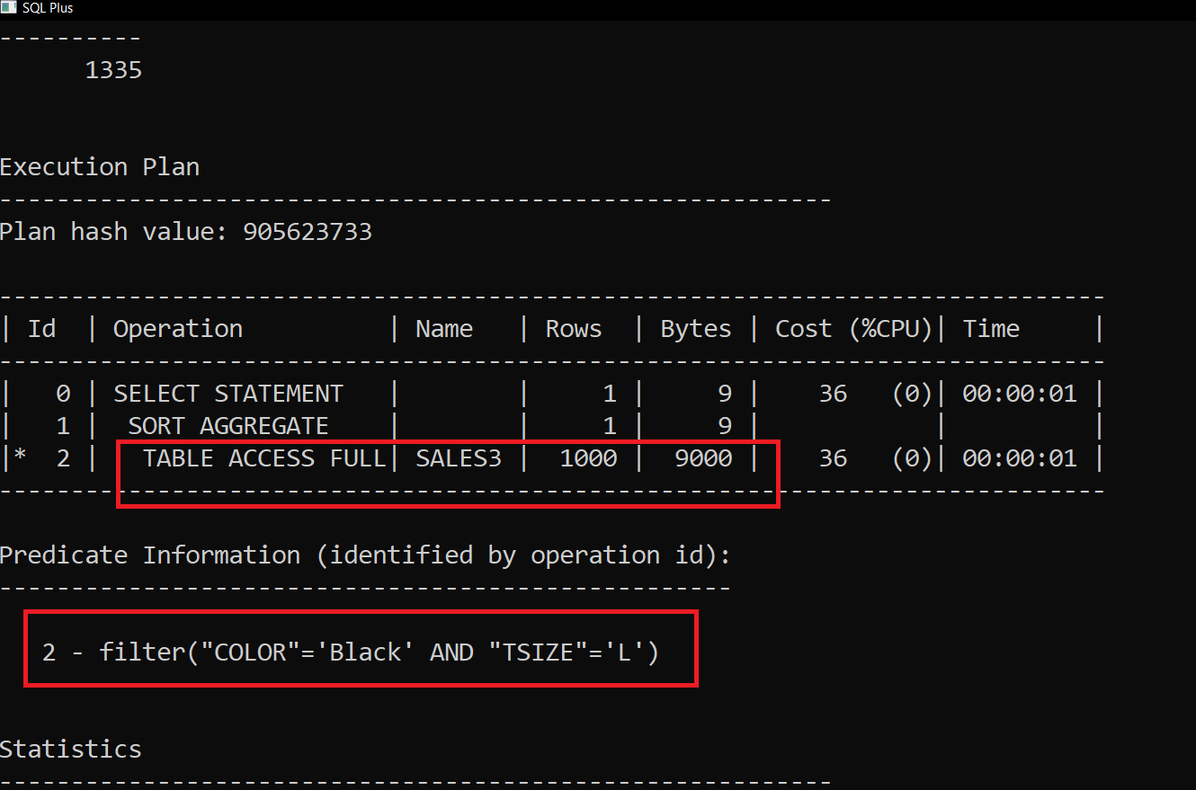

Notice The single column index of Color column is not getting used.

Let’s drop this index.

drop index Scott_Sales3_Color;

Now let’s create a bitmap index on only column TSize of Scott’s sales table.

Create Bitmap Index Scott_Sales3_TSize
on Scott.Sales(TSize);

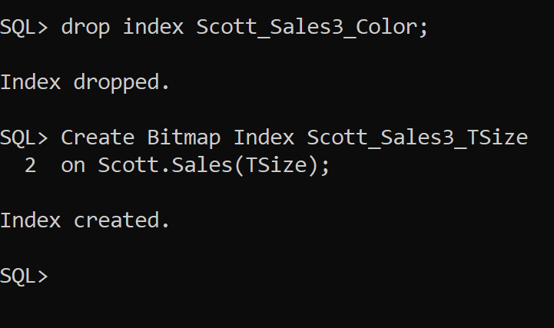

After indexing the column TSize again reset memory and environment

Alter system flush buffer_cache;
Alter system flush shared_pool;
SET AUTOTRACE ON
Cle Scr

Now execute the same select statement:

select count(*) from Scott.Sales3
where color = 'Black' And TSize = 'L' ;

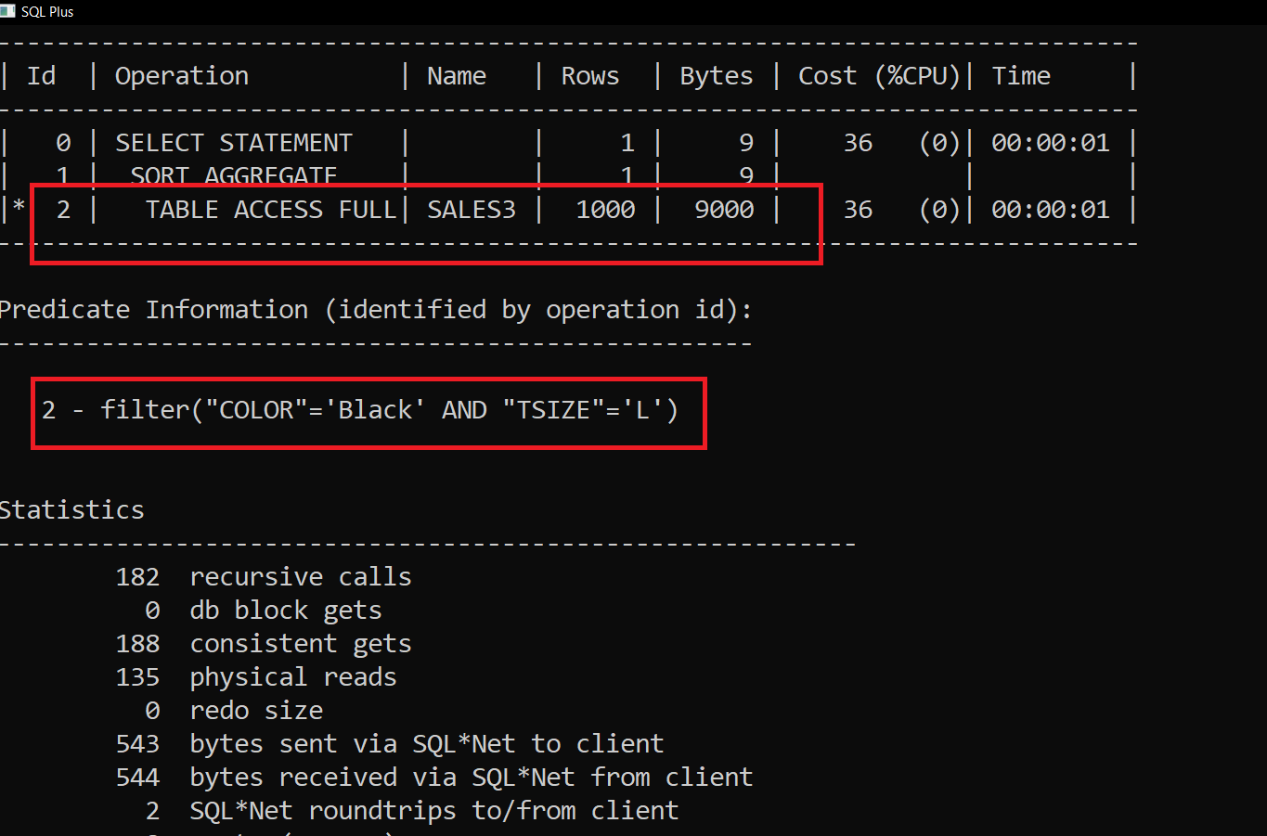

Notice Again the single column index of TSize column is not getting used.

Let’s drop this index also.

drop index Scott_Sales3_TSize;

That means we should create a composite index of Color and TSize values!!

Reset memory and environment.

Alter system flush buffer_cache;
Alter system flush shared_pool;
SET AUTOTRACE ON
Cle Scr

Creating Composite Index

Create Bitmap Index Scott_Sales3_Color_TSize
on Scott.Sales3(Color, TSize);

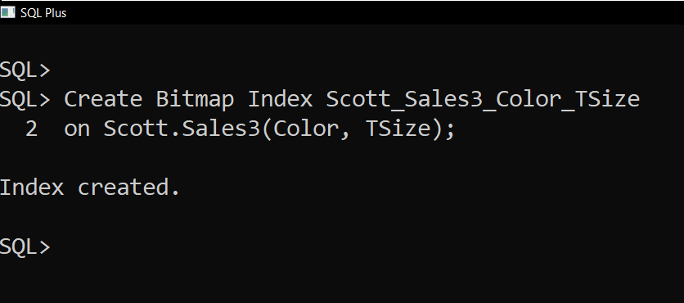

After creating the composite index again reset memory and environment

Alter system flush buffer_cache;
Alter system flush shared_pool;
SET AUTOTRACE ON
Cle Scr

Now the final testing time comes…….

Now again execute the same select statement:

select count(*) from Scott.Sales3
where color = 'Black' And TSize = 'L' ;

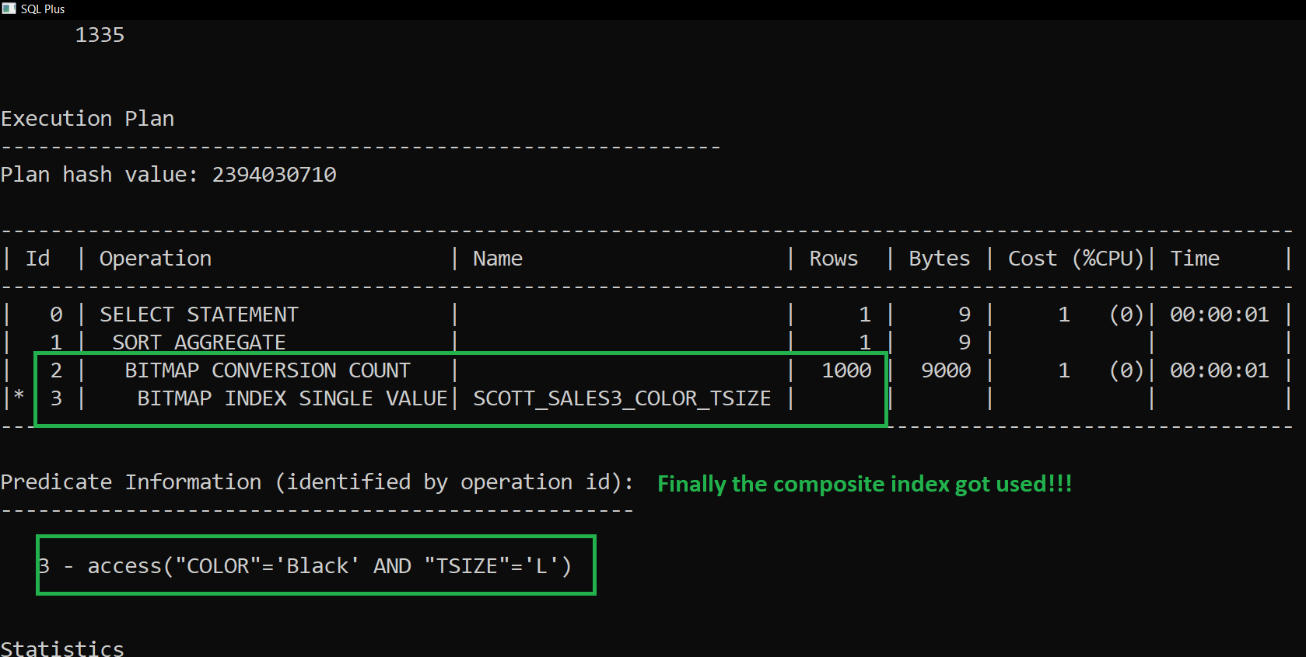

Finally, the index (composite index) got used and Full Table Scan got avoided!!!

If only one column from composite index is used in the where clause.

Alter system flush buffer_cache;
Alter system flush shared_pool;
SET AUTOTRACE ON
Cle Scr

select count(*) from Scott.Sales3
where color = 'Yellow';

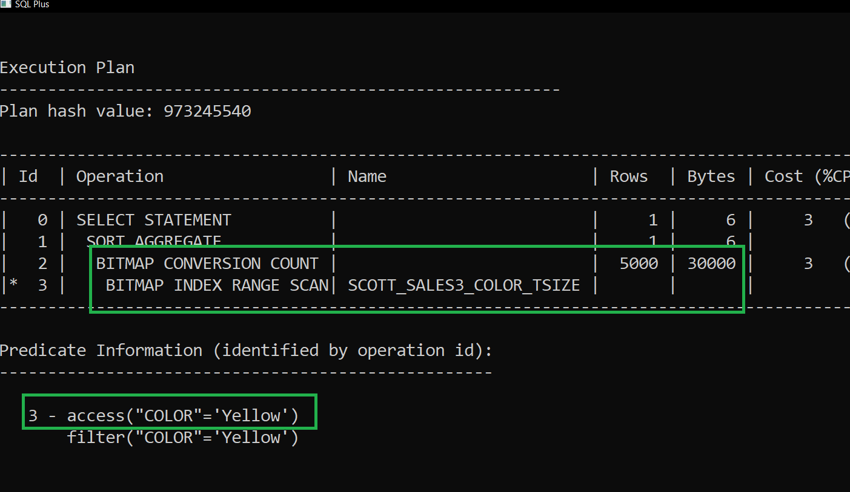

Note Here it used the index as it was just counting rows.

But if all the columns or some columns have to be shown then index will NOT get used!!

Alter system flush buffer_cache;
Alter system flush shared_pool;
SET AUTOTRACE ON
Cle Scr

select * from Scott.Sales3
where color = 'Yellow';

As it will become difficult for it to know Yellow with and Sizes rowids, so better to do full scan.

Where Clause has both the indexed columns with OR operator.

Alter system flush buffer_cache;
Alter system flush shared_pool;
SET AUTOTRACE ON
Cle Scr

select count(*) from Scott.Sales3
where color = 'Black' Or TSize = 'L' ;

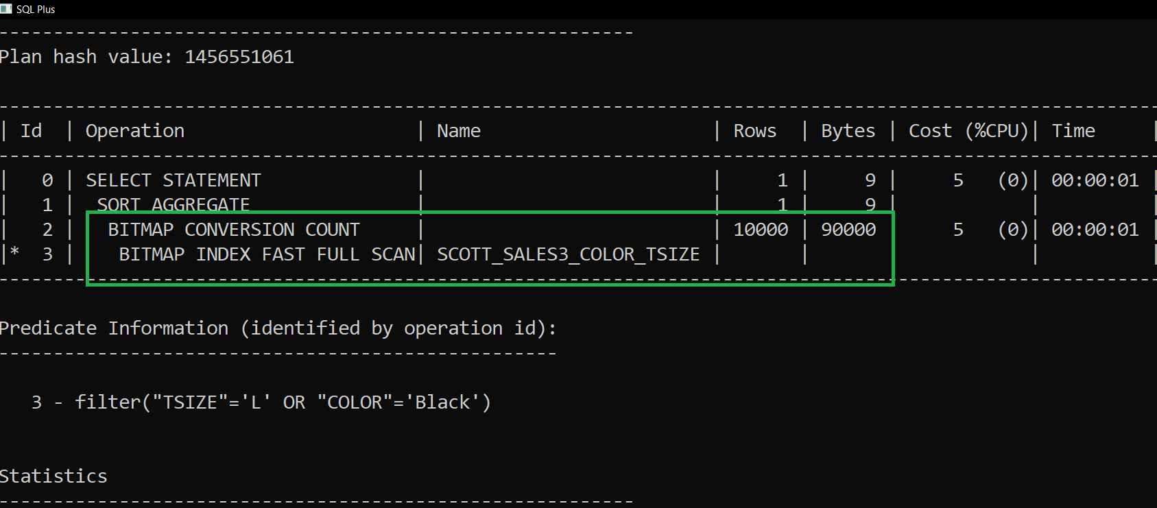

Other columns in where condition along with composite index columns.

Alter system flush buffer_cache;
Alter system flush shared_pool;
SET AUTOTRACE ON
Cle Scr

select count(*) from Scott.Sales3
where color = 'Black' And TSize = 'L' And Qty > 3;

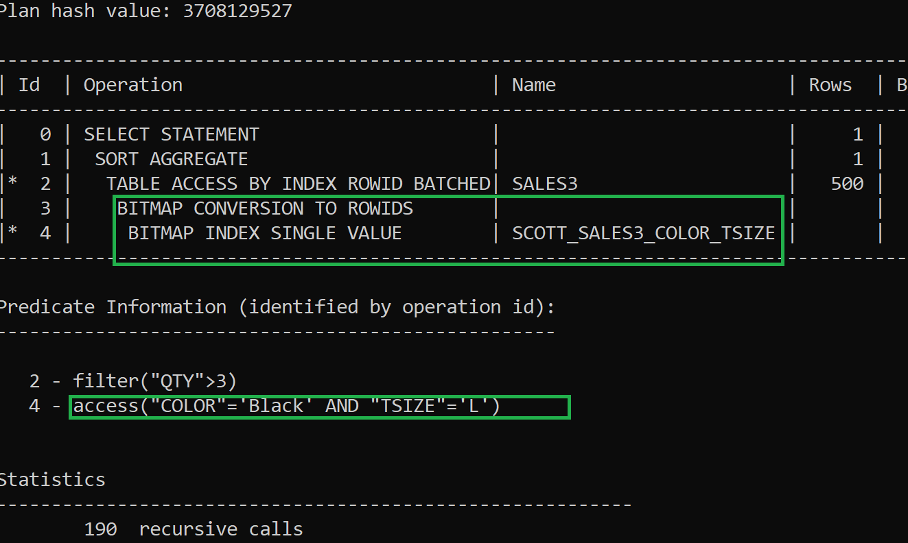

Clean up Code:

Drop the composite index.

drop index Scott_Sales3_Color_TSize;

